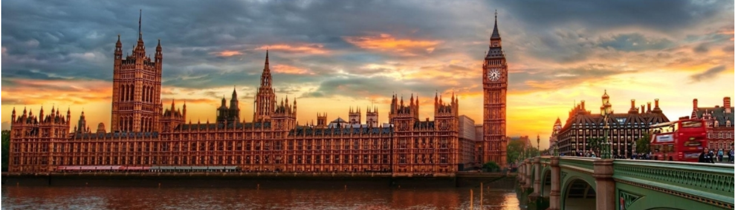

**Background:**

London is one of the most popular cities in the world. It is a cosmopolitan area that has so many attractions to locals and tourists alike. It is home to some of the most famous buildings and landmarks in the world such as St Paul’s Cathedral, Big Ben, Buckingham Palace, The London Eye, Wembley Stadium and Lord’s to name just a few.

Being so multicultural, it would make sense for London to cater to the needs and wants of their residents. Particularly when it comes to cuisine.

As a South African, I am quite used to popular food-chains coming to our shores. Mainly from USA, but also from Europe. They always come with a big reputation with lines regularly extending a long way out of the store, and people not being too concerned with having to wait a while to get their food or drinks. Now, we are all familiar with huge fast-food chains such as McDonalds and KFC, and their popularity has not decreased as they have been in South Africa for many years now - KFC is in fact celebrating 50 years in South Africa in 2021. However, some recent examples of (mostly) American chains establishing their brands here include Burger King, Dunkin’ Donuts and the famous coffeehouse, Starbucks. Not all these chains have lasted for as long as they would have anticipated.

I want to *flip the script*, so to speak, and introduce London to some truly South African cuisine. Many South African expatriates will be happy to have a taste of home, while natives will be curious to find out if the hype is worth it all.

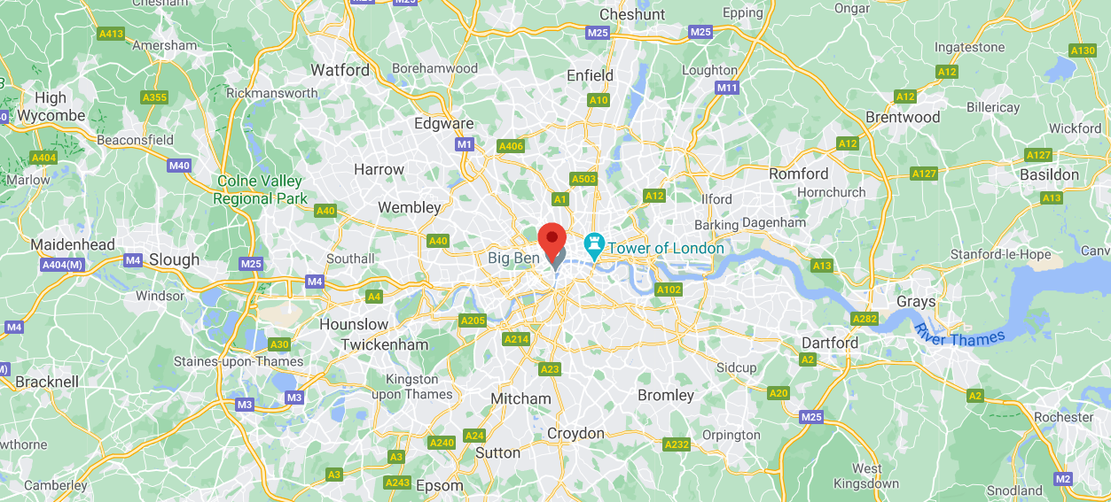

**Business Problem:**

Having been in the city in mid-2019 for a visit, I did not see too many South African shops or restaurants. Not that it bothered me too much as a tourist. But I can only imagine that a South African expatriate would want a bigger taste of home for those days when they may feel homesick.

I want to solve this problem and find the best possible spot to open a proudly South African restaurant in the heart of London.

South Africa is famous for food and snacks such as biltong, the Gatsby, vetkoek, potjiekos, bunny chow as well as boerewors, among others. The restaurant I intend to open will have all of these and more on its menu, and no doubt warm the heart – and stomach - of those familiar with them and convert those who are new to it.

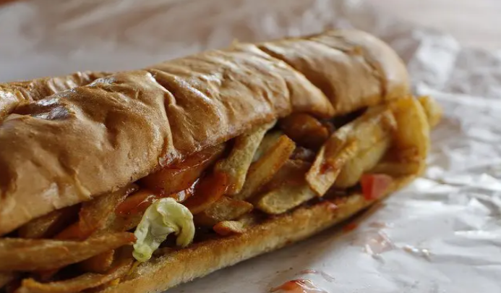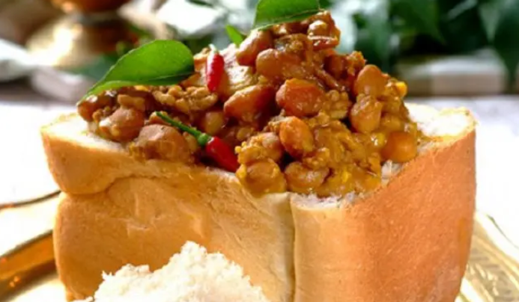

When starting any new business, one of the main issues is location. The location is of great importance, as it needs to be accessible to large numbers of people. Many businesses fail due to their actual store being in an inconvenient area, or far away from where many of their target customers reside or work.

London is famous for its Underground/ Tube transportation system as it transports many residents across the city, thus lessening the road traffic. These people do not need to worry about parking and because this tube system is so reliable and efficient, can thoroughly enjoy themselves when dining out.

**Data:**

Using location data from Foursquare, I want to find the ideal place to open this South African Restaurant. Noting that it needs to be in a public place that is relatively easy to find.

For example:

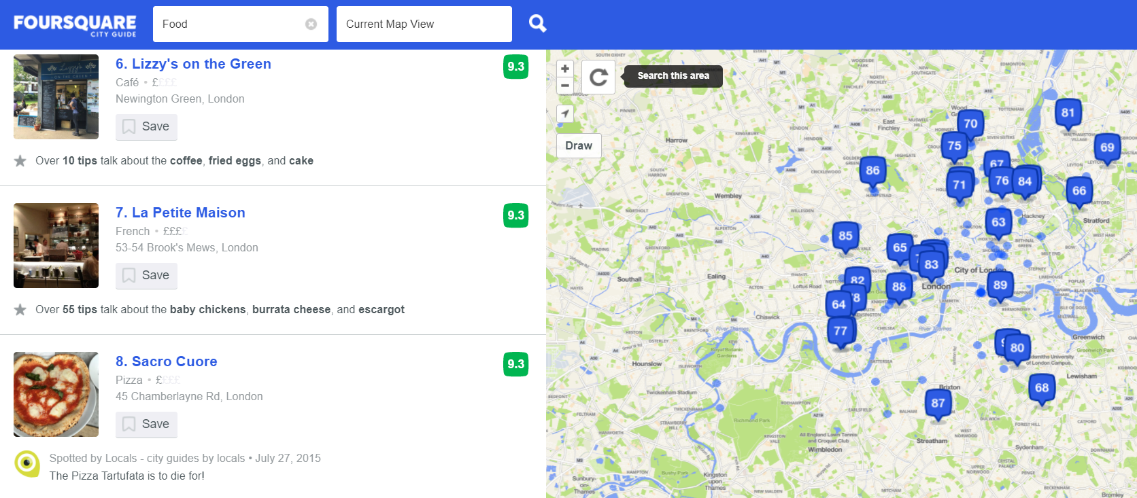

I will also scrape the “List of restaurants in London” page from Wikipedia to ascertain whether such a restaurant is already open in London, as the one I intend to open.

For example:

